Design of Player B

For our second learning algorithm, we decided to research and implement an algorithm that already exists rather than create another one of our own. We thought that this would contrast quite well by using our self-created algorithm versus a well known algorithm. Throughout the project we have always been particularly interested in the reinforcement approach as we believe this is very similar to how the human brain is likely to operate when learning, so we focused our research specifically on reinforcement learning algorithms. From there we found several different types of reinforced learning algorithms which were also covered in our lectures; which in-turn led us to Q-Learning.

Q-Learning is an example of reinforcement learning that is often used in path finding such as in basic robots [1]. It implements a simple Q-Learning Algorithm which is as follows:

Q(s,a) = Q(s,a) + α x [ ( r +1 ) + γ . ( maxα Q( s + 1, a) ) - Q(s,a)]
old value reward estimate of optimal future value old value

{Where s refers to state, a refers to an action, α is the learning rate and gamma is the discount factor}

It primarily works based on the gamma range of 0 to 1. If gamma is closer to the base value of 0 the algorithm will cause the program to take immediate rewards however as gamma tends towards values closer to 1 then the program will consider greater rewards that do not occur immediately.
This causes it to tend toward the optimum in Q-Learning theory. It initialises this by (excluding when we have the optimum function) assuming we have the optimum and updating the function at each stage until the optimum is reached. The said update process works by:

- Executing the Q table of values Q(s,a)
- The algorithim will then 'observe' the state s.
- The action a will be then be procured via the observation of said state.
- From this action the reward is found and a new state sx is found
- The new Q-Value for the next state is then found using the reward found from the last expansion and the maximum reward for the next state. (Using the formula above.)
- Set the state to the new state found in the previous step and repeat this method until the the optimum is reached. [2]

Reference: [1] http://computing.dcu.ie/~humphrys/Notes/RL/how.q.html,
[2] http://mnemstudio.org/path-finding-q-learning.htm

Q-Learning is implemented with varying degrees of success depending on how complicated the problem. In the mat-lab example it takes 400+ attempts before it starts to implement an accurate path. This shows there is a vague inefficiency to the learning however by a larger amount of tries it has deduced the best path so the agorithim if not implying a time efficiency is optimal. It also works differently in manner if you program it to be greedy or conservative based on the coefficients set in the algorithm. If you program α to be close to one it will learn only recent info and vice versa if set to be close to zero. It can show earlier signs of winning if you set the coefficient to be close to one whereas if you set it closer to zero it will only learn later information which will search for the optimal path but in a much slower method.

An initial concern that we had during our research of Q-Learning, was that it commonly uses table lookups to store and retrieve data. This was a route that we didn't think could be sustainable because having to access tables could significantly slow our algorithm down as the state space grows. Especially as the test consisted of 1000 games, we felt the algorithm might be too slow to complete the test in a reasonable time. Furthermore we lacked cognitive experience with using Mysql in a java environment, which would be required for a table system. After some further research on the internet, we located a web page which provided a more concise outlook on how to implement the q-learning in a different manner to that usually parsed: [3]. Which led us to implement a neural net method to store our values for our take on the Q-Learning code. This began to further research on neural networks for this method.

Reference: [3] http://stackoverflow.com/questions/13455049/q-learning-in-combination-with-neural-networks-rewarding-understanding

The neural net we believe added more efficiency to our code and would allow it to perform more effectively against an opponent that is also learning though in a different manner.

After implementing the Q-Learning algorithm we believed it would be very successful against the random AI that we produced, as its a proven algorithm which was mostly likely to improve the quickest due to it receiving a reward to find its optimal state of winning the game constantly. We found very surprisingly that the Q-Learning Algorithm results against the random AI varied significantly when completing 1000 games. We believe this must be due to the randomness of the player causing the algorithm to learn against one type of random play but it not being effective the next game. Therefore the Q-Learning Algorithm was unable to get to it's optimal state quickly and had to constantly alter its moves, causing the random AI to win more than expected.

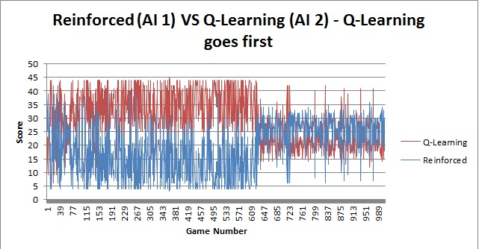
Even after this crash test we still presumed that the algorihtm would also win against the Reinforced Learning Algorithm we created due to its structure being more accustomed to a mancala game e.g. having a finite number of states and probabilities from which to choose from. However our prediction was not correct, during the test we found that the Q-Learning Algorithm lost on most occasions, even though the loss varies by 20% or more in some cases. From analysing the results we can see that the Q-Learning became undone by the random element which is persistant in the Reinforced Learning Algorithm, as the Q-Learning was unable to learn faster or maintain its wins after 500 games. This can be seen on the following graph:

The graph demonstrates that the Q-Learning for the primary 600 games is scoring higher, implying that it is learning more but does not necessarily translate to winning, however after this period the reinforced learning is winning more and scoring higher as it is has gathered enough data to start applying it to winning games. This is because the Q- Learning algorithm has no means for coping with losses except less 'rewards' will begin to tend away from the optimum value and will need to find another route to win so it has to restructure itself. This means Reinforcement Learning begins to take control of the game. This is further iterated when past 1000 games the reinforcement algorithm shows a much higher percentage of wins as since the Q-Learning algorithm isn't getting rewarded it can''t cope and begins to lose constantly.

So in consistency we realised why the Q-Learning algorithm performed to the opposite of our expectations. Against a random player it lost due to the inability of this algorithm to react efficiently to another player, as the algorithm is good at solving stand alone problems and reacting to situations that do not interchange situations. So as each time the random element changed its method, Q-Learning had to reset itself to react to a different situation. This is a similar situation to the other algorithm, it performs to an average level as the reinforced learning is slightly less random than the random opponent. However there was still a random element causing Q-Learning to reset itself and its aims occasionally causing an insipid focus on a final object by the time Q-Learning was able to react the reinforced algorithm was closer to an optimum path so it carried on winning. To fix this we would need to implement a way for Q-Learning to react and predict opponents moves more efficiently rather than solely heading for its own aim.

